**Game Documentation**

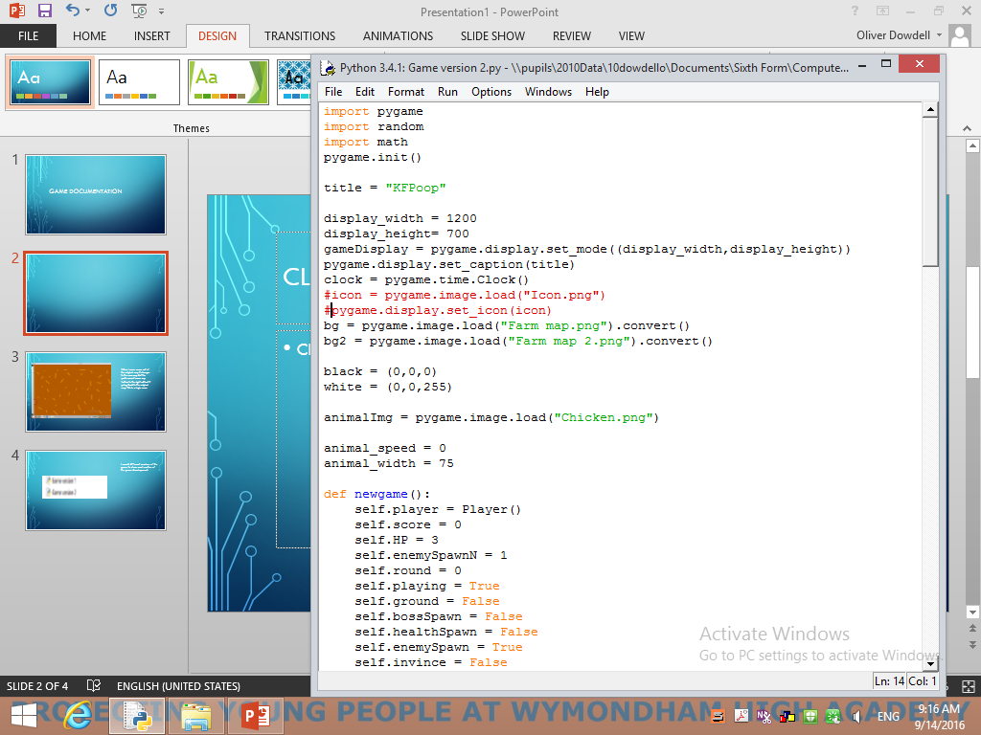My variable names are sensible and it is obvious what kind of data they hold. Sensible variable names make checking and debugging the code a lot easier than trying to review random variable names which don’t make sense. For example “bg” is the background and “icon” is the game icon in the top corner of the window.

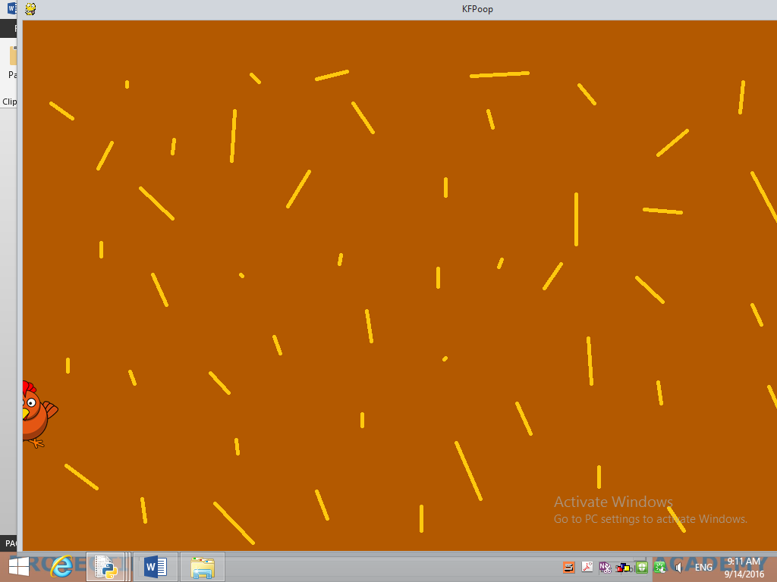Also the names of the files which I save to load images are sensible. E.g. “Farm Map” is the map of the farm for my game.

When I move across out of the original map it changes to the new map but the sprite cannot move any further to the right without it going back to the original map. This is a logic error.

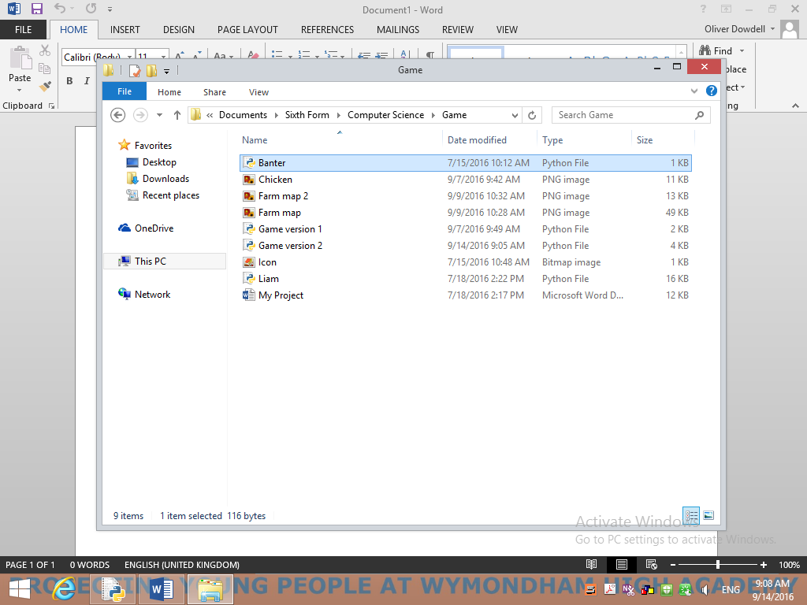 I saved different versions of the game to show each section of the game development. 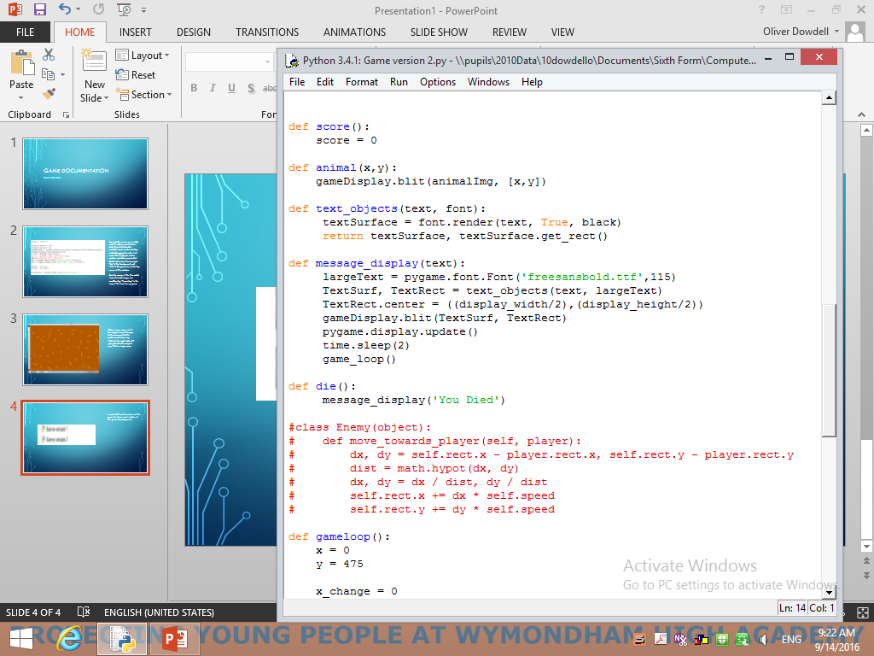 I used functions all throughout the code the make the code easier to understand and solve problems which begin to arise. Like the variable names the functions have sensible names and have gaps in between each one to make it clearer to read.

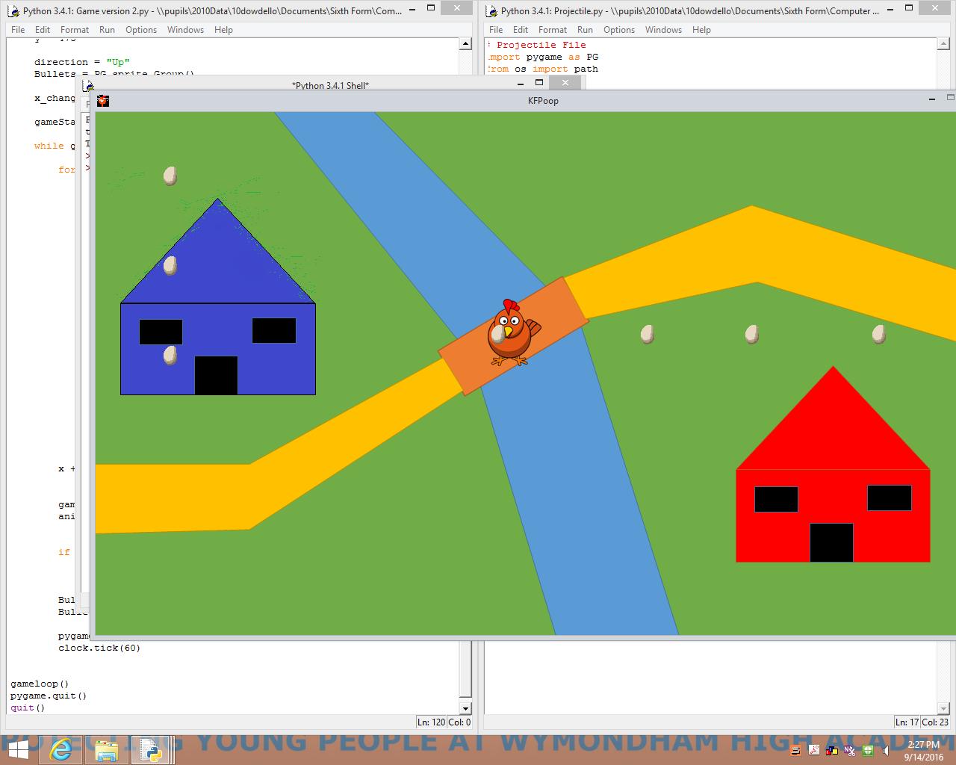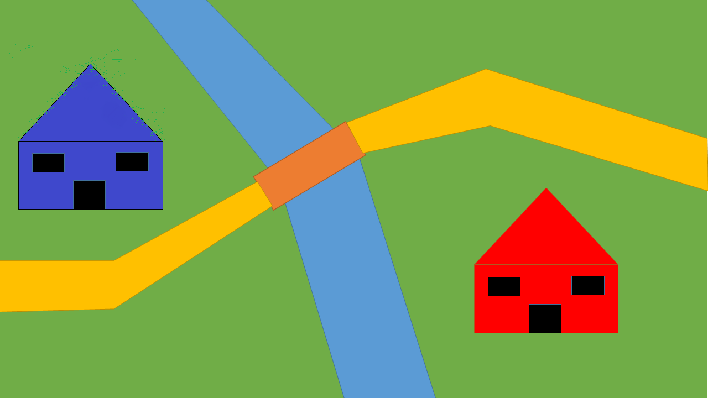I drew a map to use for my game world on paint.

When I added the eggs to be fired from the chicken, the eggs after around 2 minutes would come back around the map and go past again (as shown). This was an error as I didn’t want the eggs to come back around and when they went off the screen I wanted them to not come back.

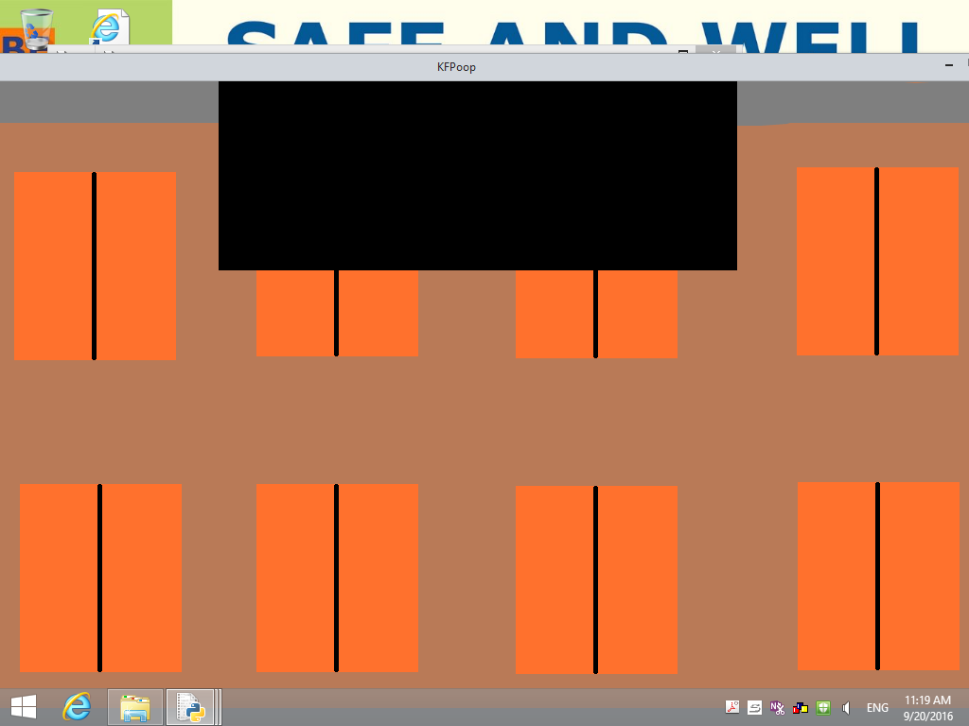

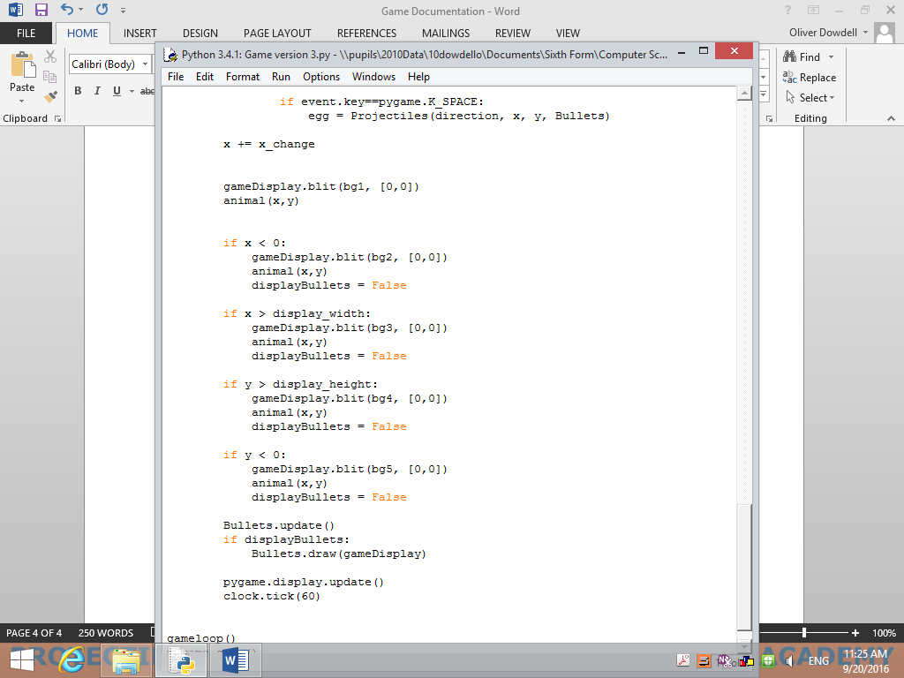

Instead of commas in between the x and y I had a full stop which meant that I had the above error. Having a full stop instead of a comma seemed to mean that the spawn point for my game was not as intended and a black box was in the screen (as seen above).

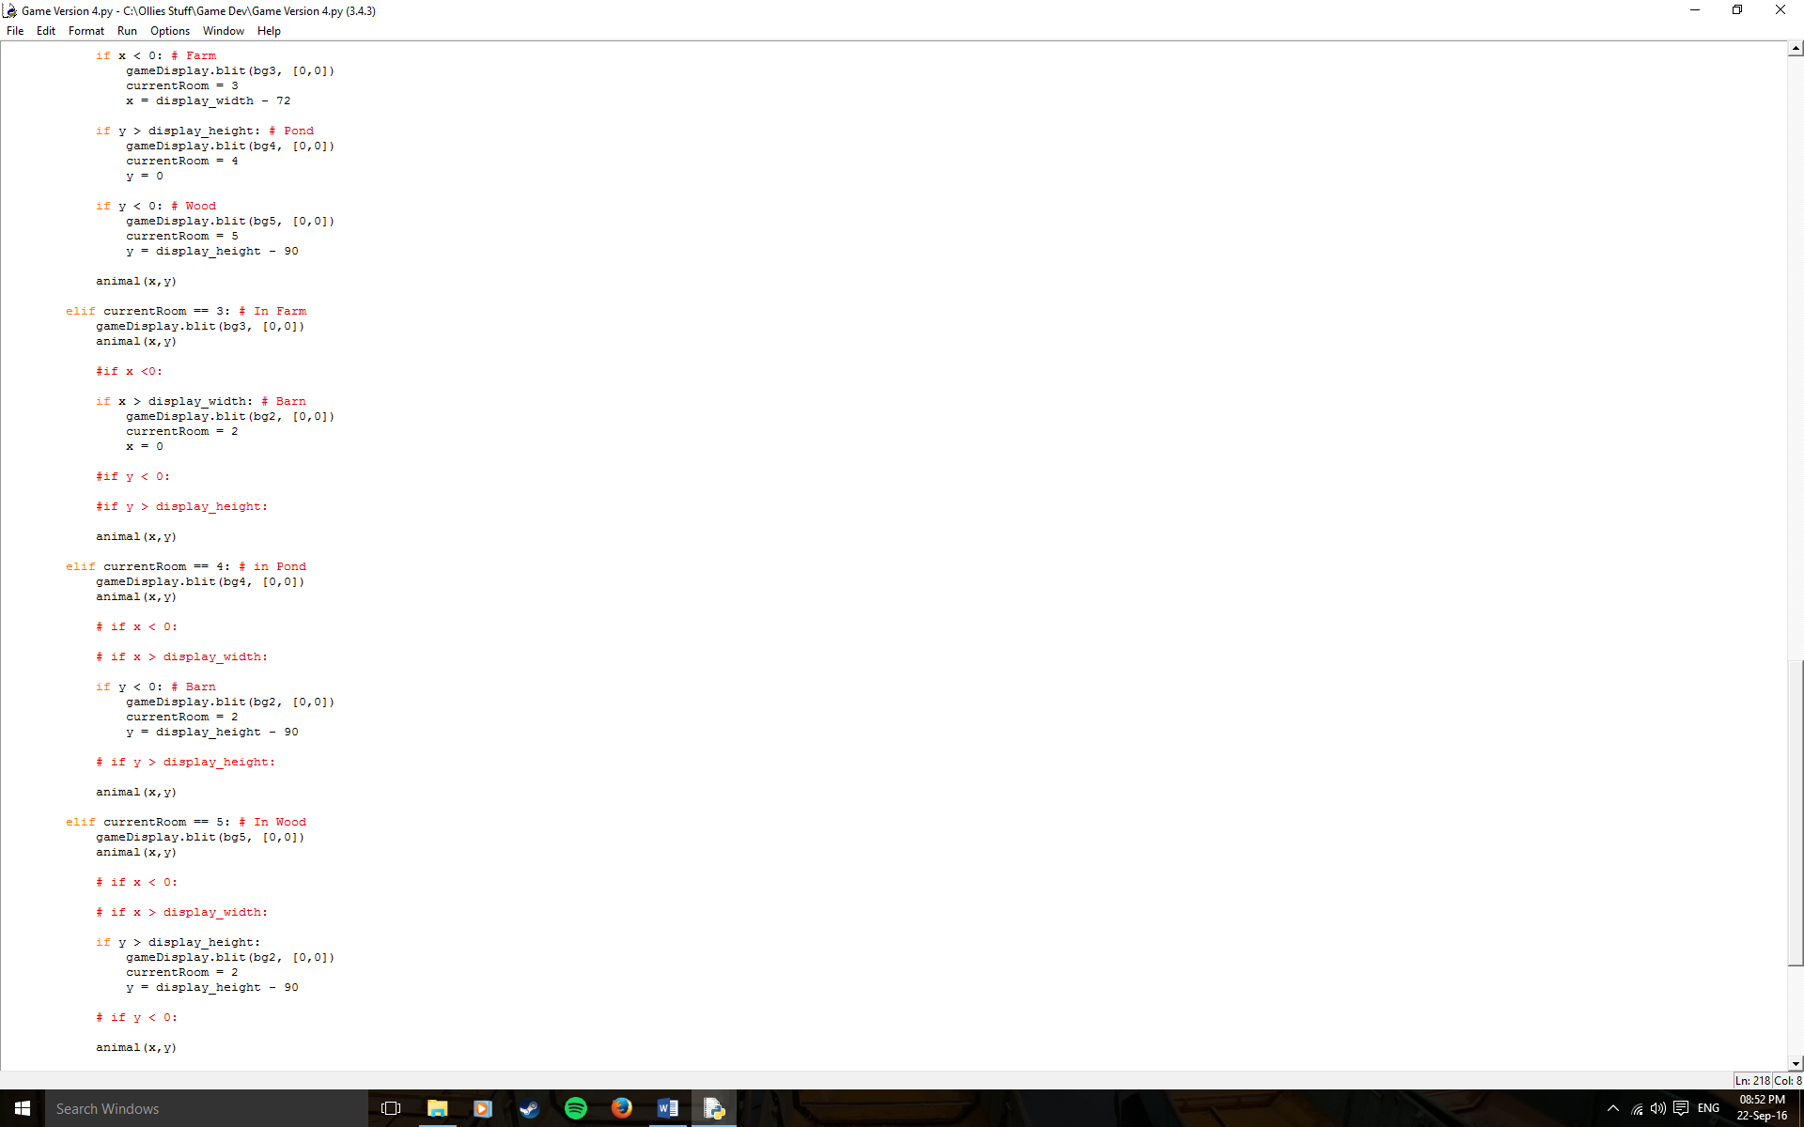

The above code shows how I implemented moving into different rooms by moving off the side of one screen and into another. A nice feature of this is when the chicken moves from one screen to the other he emerges on the new screen on the same y axis that he exited the previous to give the effect of the world all being connected rather than it seeming as if the chicken has teleported into a new separate place. It helps connect the world together.